Task-1 Draw a labeled diagram of a desktop PC, clearly marking the motherboard, CPU, RAM, GPU, and both HDD and SSD storage compo.

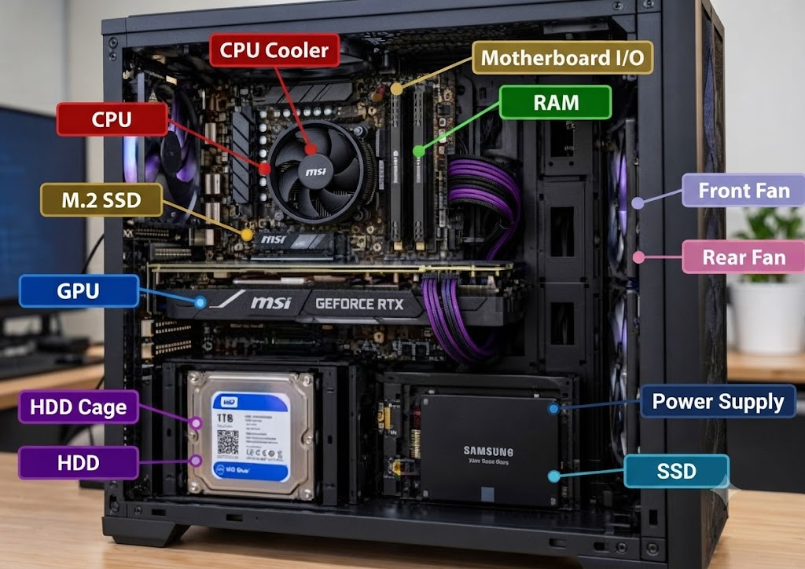

Task-2 Create a comparison table showing the main differences between HDD and SSD storage in terms of speed, durability, and typical use cases. Hint: Think about which one is faster, which is more shock-resistant, and where you would usually find each type (laptop, gaming PC, etc.).

Differences between HDDs and SSDs:
Feature | HDD (Hard Disk Drive) | SSD (Solid State Drive)
Technology | Uses magnetic spinning disks and a mechanical read/write head. | Uses flash memory microchips with no moving parts.
Speed | Slower (typically 80 to 160 MB/s). Booting and loading take noticeably longer. | Much faster (500 MB/s to over 7,000 MB/s for NVMe). Provides fast boot times and quick file transfers.
Durability & Shock Resistance | Lower; moving mechanical parts make it vulnerable to drops, bumps, and physical shock. | Higher; lack of moving parts makes it resilient against physical shock, vibrations, and drops.
Typical Use Cases | Mass data archiving, large media backups, budget-friendly desktops, and server storage. | Operating system boot drives, modern laptops, gaming PCs, and high-performance workstations.

Task-3 Write a short explanation (2-3 sentences each) describing the role of the CPU, RAM, and GPU in running a game like PUBG or Free Fire on a PC.

Here is a breakdown of how the CPU, RAM, and GPU work together to run a game like PUBG or Free Fire:

CPU (Central Processing Unit)
- The CPU acts as the "brain" of your PC, handling core game logic, physics calculations, player inputs, and networking data during a match.

- It processes instructions from the game engine and coordinates tasks between all other hardware components to ensure smooth and responsive gameplay.

RAM (Random Access Memory)
- RAM serves as the computer's high-speed short-term memory, temporarily holding active game data, map layouts, and textures currently in use.

- This allows the CPU to access essential game files instantly without having to wait for the slower storage drive, preventing stuttering and lag.

GPU (Graphics Processing Unit)
- The GPU is responsible for rendering all the visual elements on your screen, including 3D characters, weapons, terrain, and special effects like explosions or lighting.

- It performs complex graphical calculations to deliver high-resolution images and maintain smooth frame rates for an immersive gaming experience.

Task-4 Imagine you want to upgrade your PC to run the latest version of FIFA smoothly. List which hardware components you would consider upgrading and explain why for each.

1. GPU (Graphics Processing Unit)
- Why upgrade: The GPU is responsible for rendering the entire visual presentation, including high-detail player models, realistic turf textures, stadium lighting, and cinematic cutscenes. Upgrading to a capable dedicated graphics card ensures you maintain a smooth and consistent frame rate (such as 60 FPS or higher) without visual stutter during fast-paced gameplay or replays.

2. CPU (Central Processing Unit)
- Why upgrade: Modern sports games require significant processing power behind the scenes. The CPU handles complex match physics, real-time tactical AI for all 22 players on the pitch, and physics calculations. A strong multi-core processor prevents performance bottlenecks and ensures responsive controls.

3. RAM (Random Access Memory)
- Why upgrade: While minimum requirements hover around 8 GB to 12 GB, upgrading to 16 GB of RAM provides ample headroom. RAM temporarily holds active match data, player animations, and stadium assets so your system can access them instantly without lagging during transitions or menu navigation.

4. Storage (NVMe SSD)
- Why upgrade: With game installation sizes reaching around 100 GB, traditional hard drives (HDDs) will cause painfully long load times and potential texture-streaming hitches. Moving the game to a fast NVMe Solid State Drive (SSD) drastically reduces loading screens and ensures instant asset streaming as you jump into matches.

